VPC Transit Gateway & VPC Endpoint
- Create one VPC, with 1 public subnet and 1 private subnet.
Step1: Create a New VPC
- Select VPC only.
- Enter the following details:
- Click Create VPC.
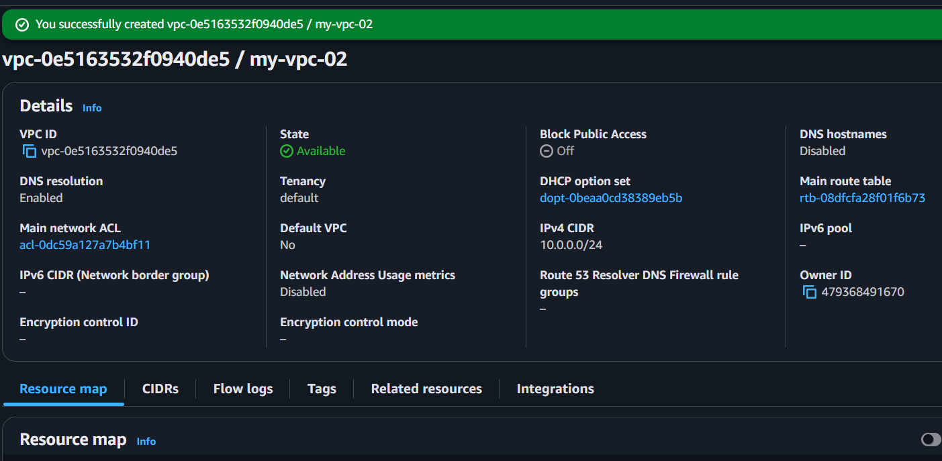
Step 2: Create a Public Subnet
- In the left pane, click Subnets.
- Click Create subnet.
- Enter the following information:
- Click Create subnet.
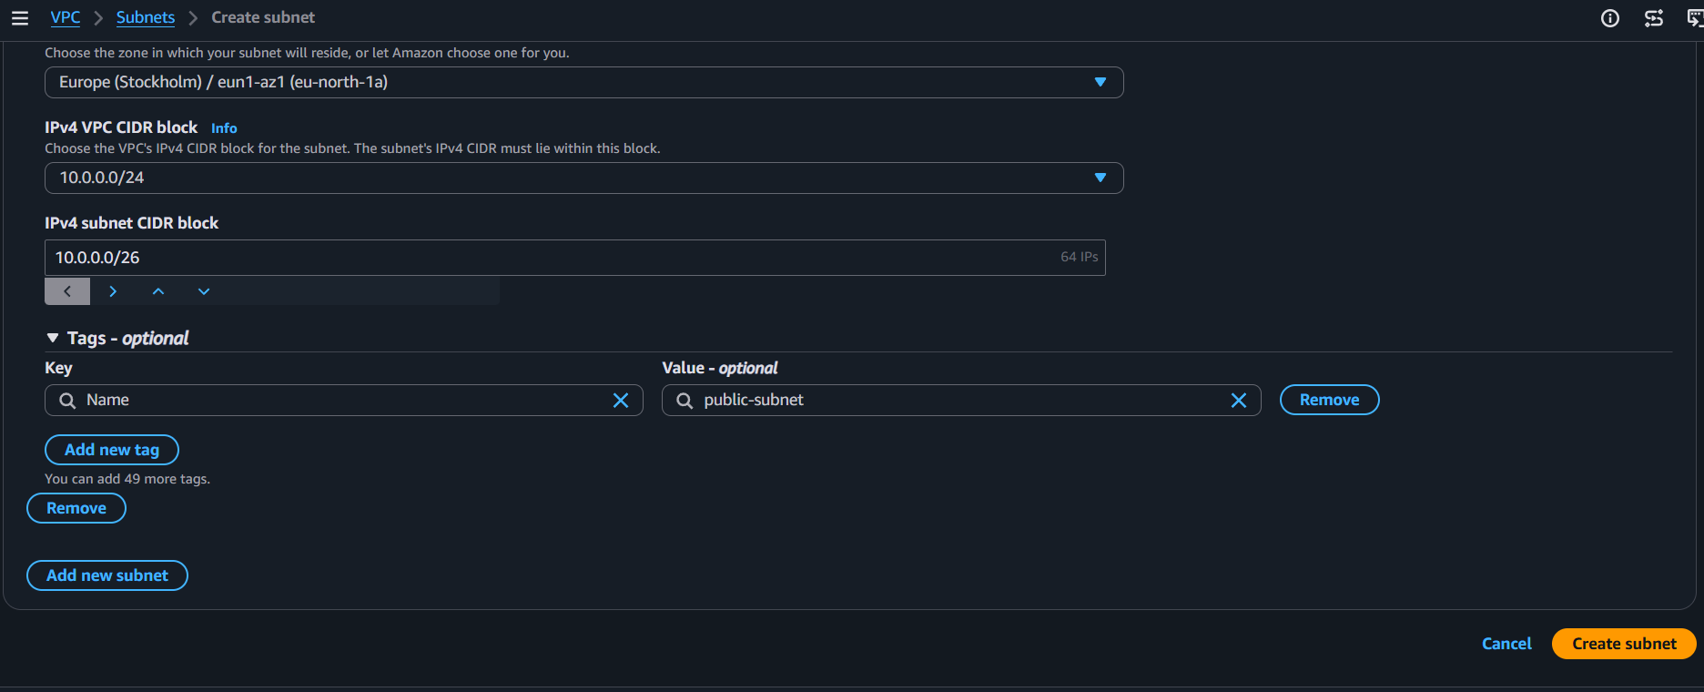
Step 3: Create a Private Subnet
  - Again click Create subnet.
  - Click Create subnet.
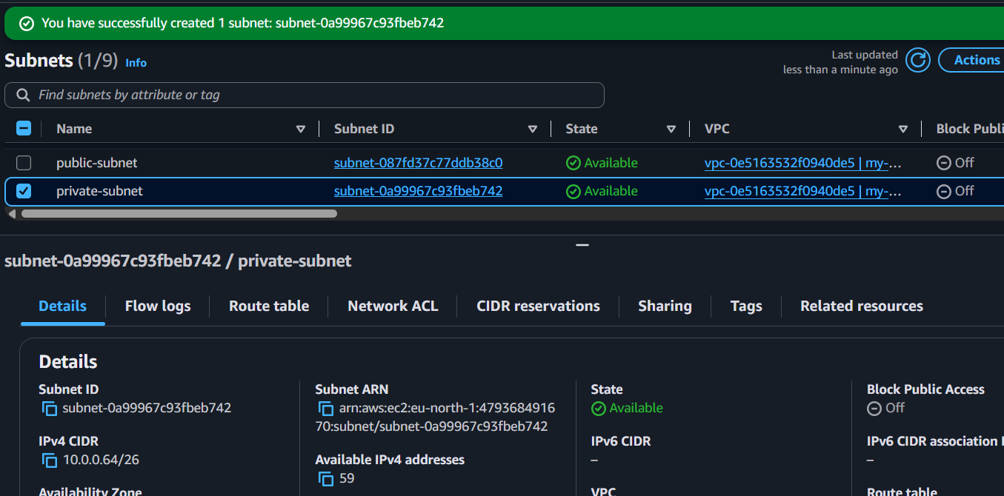
Step 4: Enable Auto-Assign Public IP for Public Subnet
  - Click Subnets.
  - Select PublicSubnet.
  - Choose the Actions menu.
  - Click Edit subnet settings.
  - Enable Auto-assign public IPv4 address.
  - Click Save.
Expected Result:
  - Instances launched in the public subnet automatically receive a public IP.
Step 5: Create an Internet Gateway
  - In the left navigation pane, click Internet Gateways.
  - Click Create internet gateway.
Step 6: Attach the Internet Gateway to the VPC
- Select MyIGW.
- Click Actions.
- Select Attach to VPC.
- Choose MyVPC.
- Click Attach internet gateway.
Expected Result:
- Internet Gateway is attached to the VPC.
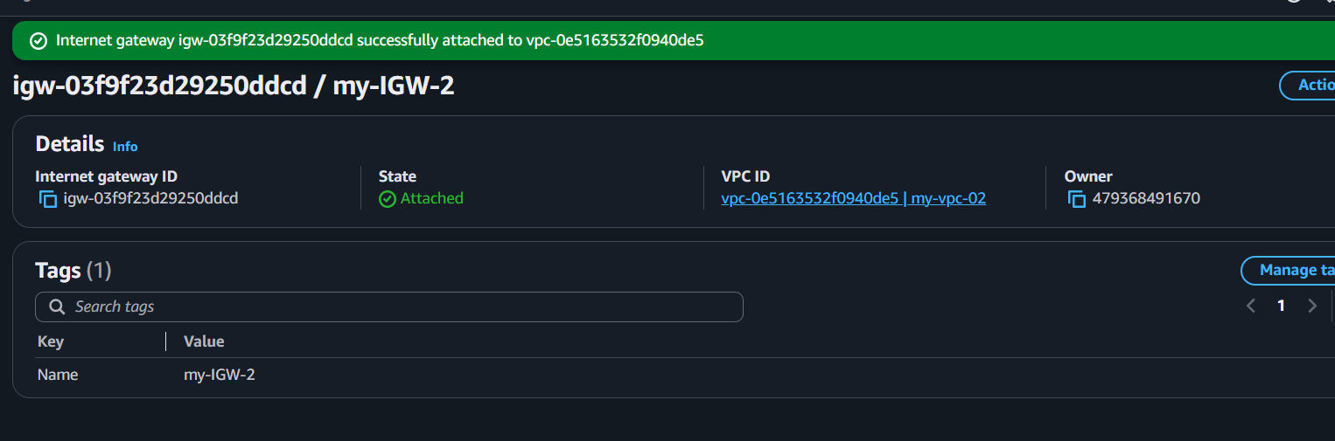
Step 7: Create a Public Route Table
- Click Route Tables.
- Click Create route table.
Step 8: Add Internet Route
- Select PublicRouteTable.
- Open the Routes tab.
- Click Edit routes.
- Click Add route.
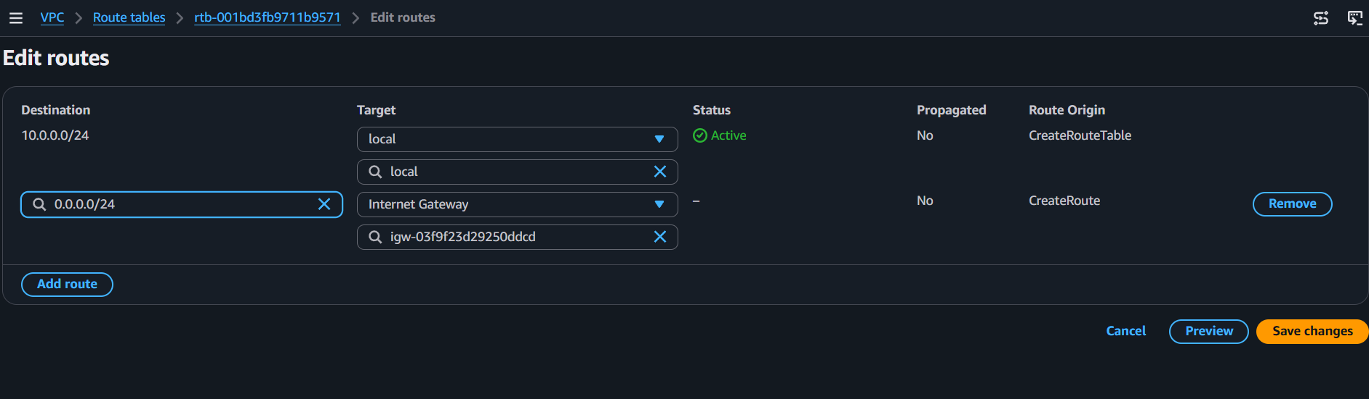
Step 9: Associate the Public Subnet with the Public Route Table
- Open PublicRouteTable.
- Go to the Subnet Associations tab.
- Click Edit subnet associations.
- Select PublicSubnet.
- Click Save associations.
Expected Result:
- Public subnet now has internet access.
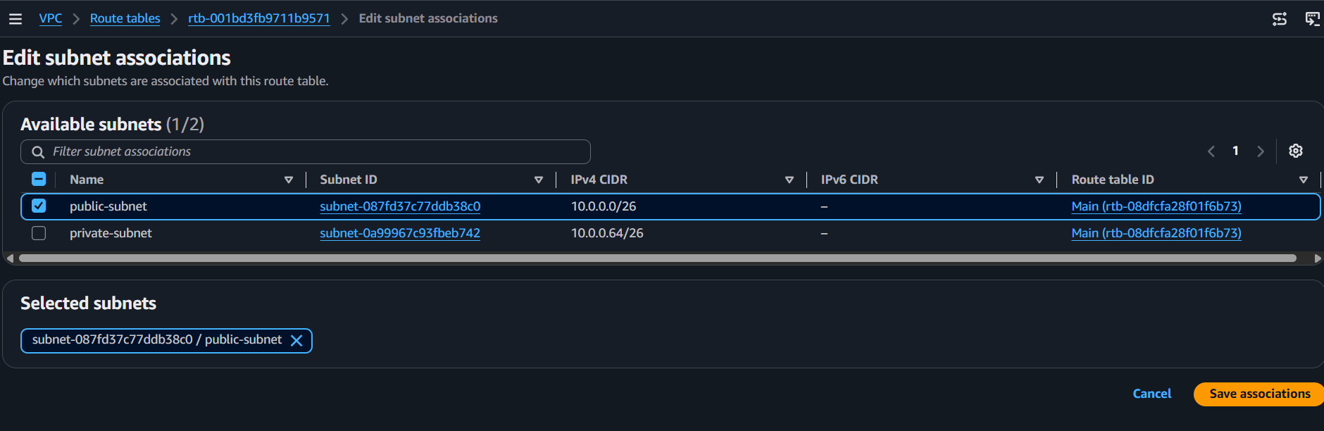
Step 10: Create a Private Route Table
- Click Create route table.
- Click Create route table.
Step 11: Associate the Private Subnet
- Select PrivateRouteTable.
- Open the Subnet Associations tab.
- Click Edit subnet associations.
- Select PrivateSubnet.
- Click Save associations.
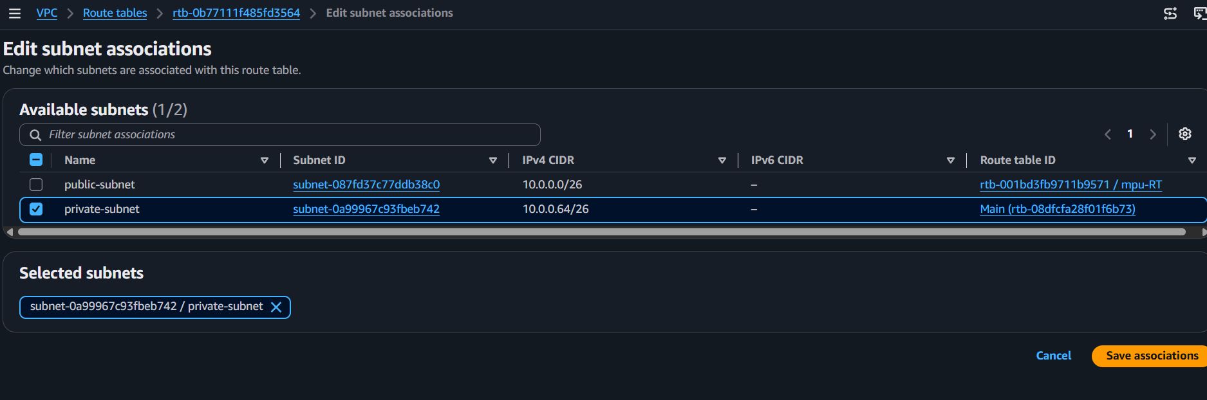
2) Enable VPC peering for cross-region.
Step 1: Change the AWS Region
- Log in to the AWS Management Console.
- In the top-right corner, click the Region drop-down.
- Select Asia pacific(Hyderabad) – ap-south-2.
You can choose any AWS Region other than Europe(Stockholm)=eu-north-1.
Step 2: Create the Second VPC
- Click Create VPC.
- Select VPC only.
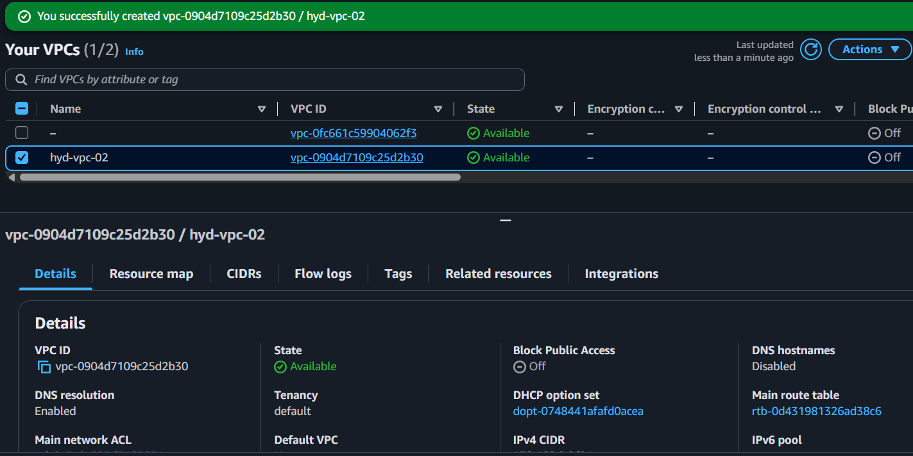
Step 3: Create a Subnet in the Second VPC
- In the left pane, click Subnets.
- Click Create subnet.
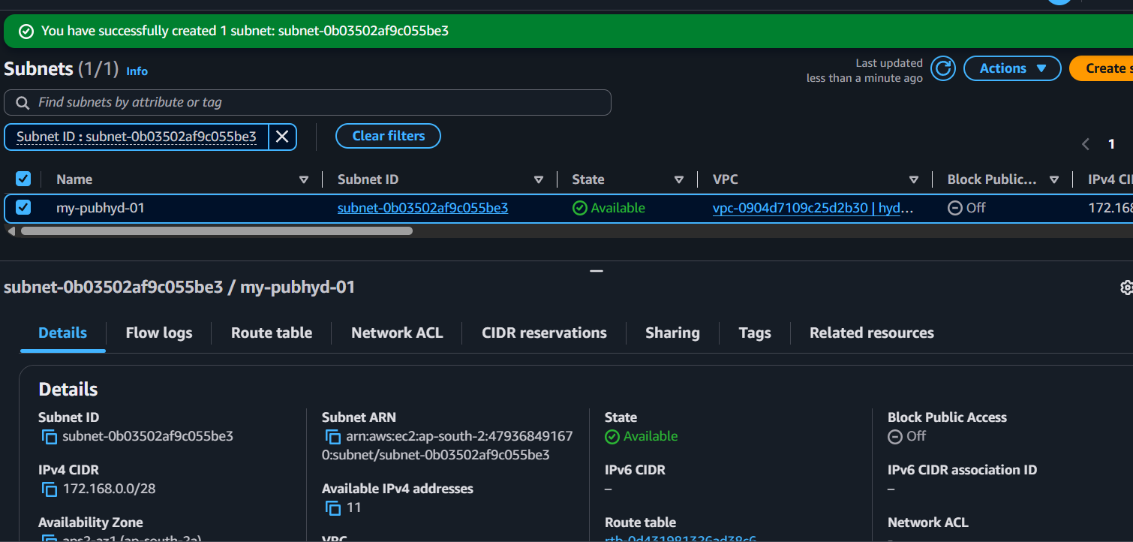
Step 4: Switch Back to the First Region
- Click the Region drop-down.
- Select ap-south-2 to eu-north-1.
Step 5: Open Peering Connections
- In the VPC Console, click Peering Connections.
- Click Create Peering Connection.
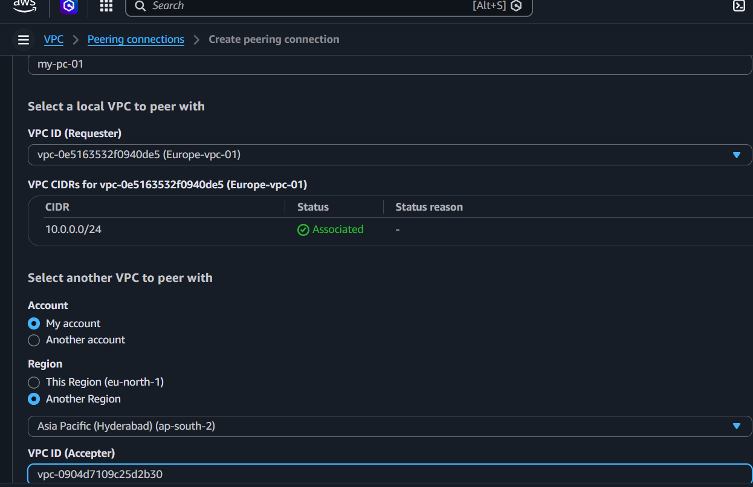
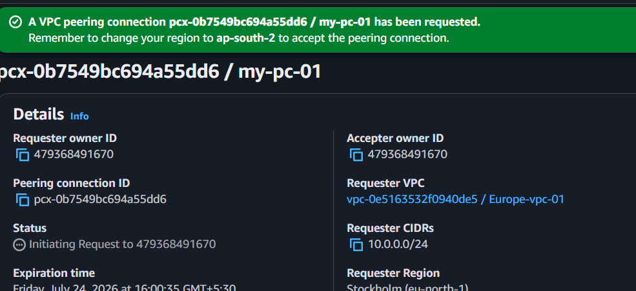

Step 6: Accept the Peering Request
- Change the Region eu-north-1 to ap-south-2.
- Open VPC.
- Click Peering Connections.
- Select the pending request.
- Click Actions → Accept Request.
- Click Accept.
Expected Result:
- The peering connection status changes to Active.

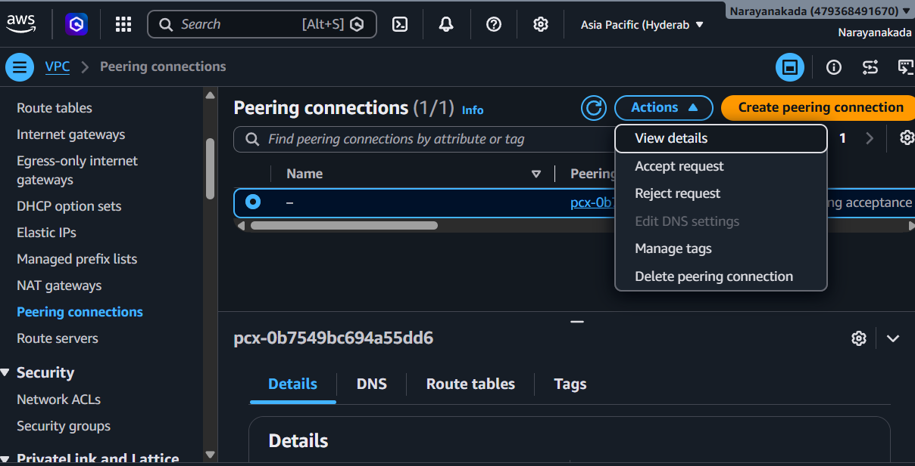
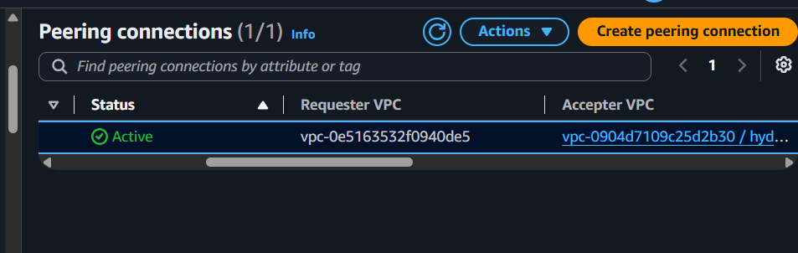
Step 7: Update the Route Table in the First VPC
- Switch back to eu-north-1.
- Click Route Tables.
- Select the route table associated with your first VPC.
- Go to the Routes tab.
- Click Edit routes.
- Click Add route.
- 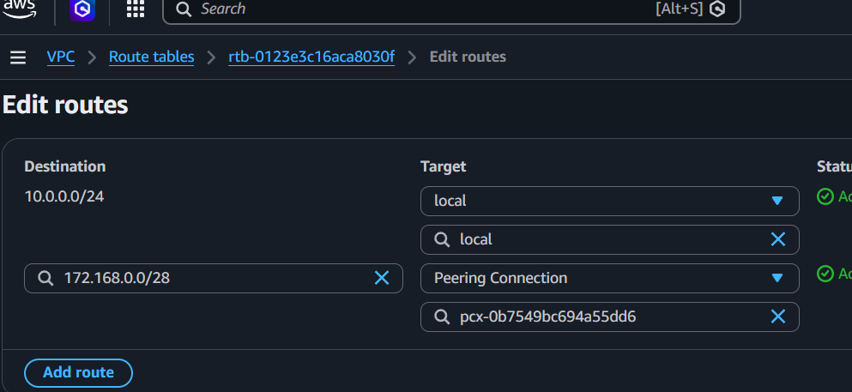

Step 8: Update the Route Table in the Second VPC
- Change to ap-south-2.
- Open Route Tables.
- Select the route table associated with MyVPC2.
- Go to the Routes tab.
- Click Edit routes.
- Click Add route.

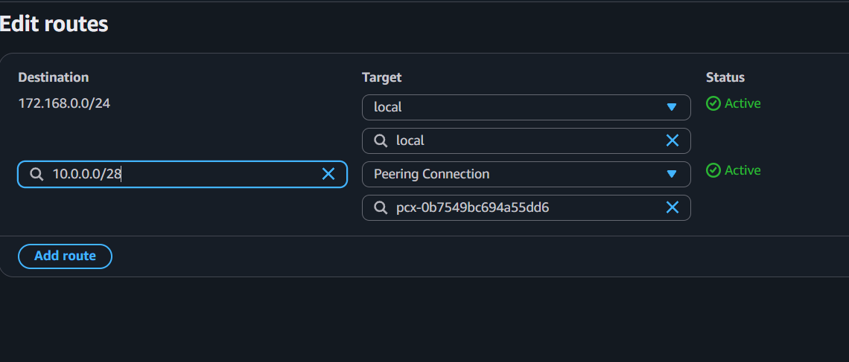
Step 11: Verify the Peering Connection
- In either Region, open VPC → Peering Connections.
- Verify that:
- Status: Active
- Requester VPC: Your VPC in eu-north-1
- Accepter VPC: MyVPC2 in ap-south-2
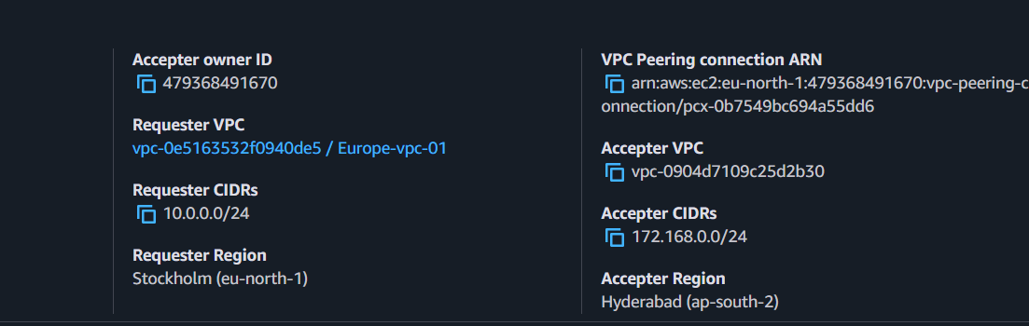
3) Enable VPC peering for cross-account (you can collaborate with your friend to do this task).
Prerequisites
Your AWS Account (Account A)
- AWS Account A
- VPC1 created
- Example:
- Region: ap-south-2
- CIDR: 172.168.0.0/24
Friend's AWS Account (Account B)
- AWS Account B
- VPC2 created
- Example:
- Region: us-east-2 (same Region is easiest)
- CIDR: (must not overlap)
Step 1: Obtain Your Friend's AWS Account ID
Ask your friend to provide:
• AWS Account ID (12 digits): 265243686408
• VPC ID: vpc-064e3fb1498ae3e05
• Region:us-east-2
Step 2: Create the Peering Connection (Your Account)
- Log in to your AWS account.
- Open VPC.
- Click Peering connections.
- Click Create peering connection.
Fill in:
- Field Value
- Name PC-narayana-01
- Requester VPC Your VPC
- Accepter AWS Account Another account
- Field Value
- AWS Account ID Your friend's 12-digit AWS Account ID
- Region us-east-1 (or your friend's Region)
- Accepter VPC Your friend's VPC
- Click Create peering connection.
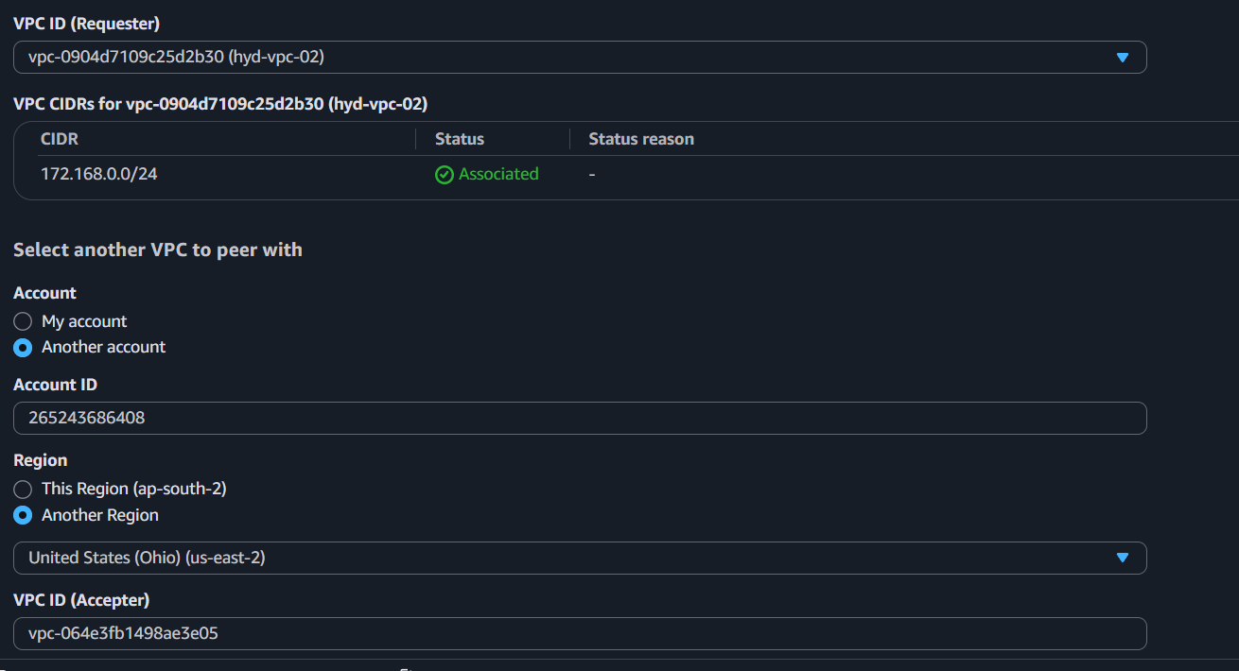
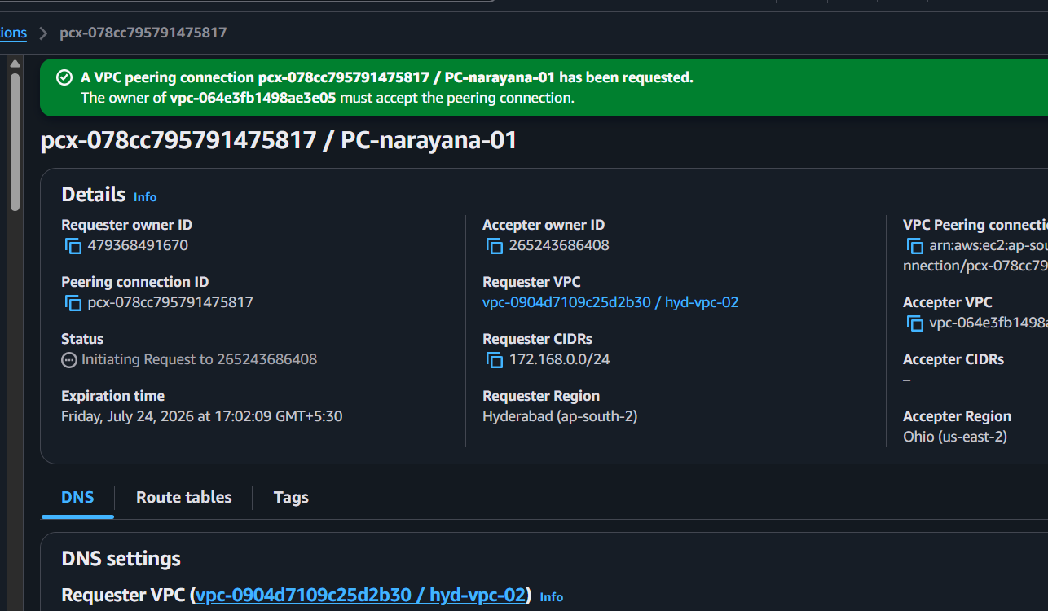
Step 3: Friend Accepts the Request
Your friend should:
- Log in to their AWS account.
- Open VPC → Peering connections.
- Select the pending request.
- Click Actions → Accept request.
The status should change to Active.
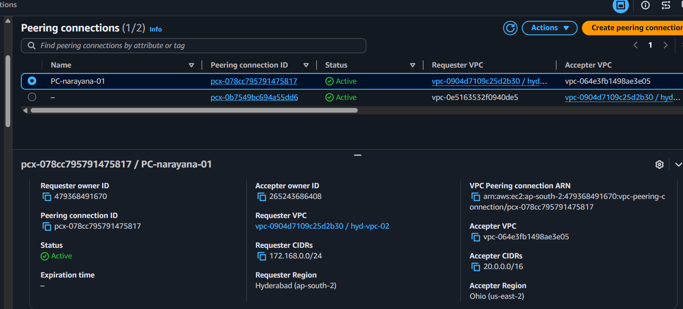
Step 4: Update Your Route Table
- Open Route Tables.
- Select the route table associated with your subnet.
- Click Routes → Edit routes → Add route.
Example:
Destination Target
192.168.0.0/16 VPC Peering Connection
Step 5: Friend Updates Their Route Table
Your friend should add:
Destination Target
10.0.0.0/16 VPC Peering Connection (pcx-xxxxxx)
Save the changes.
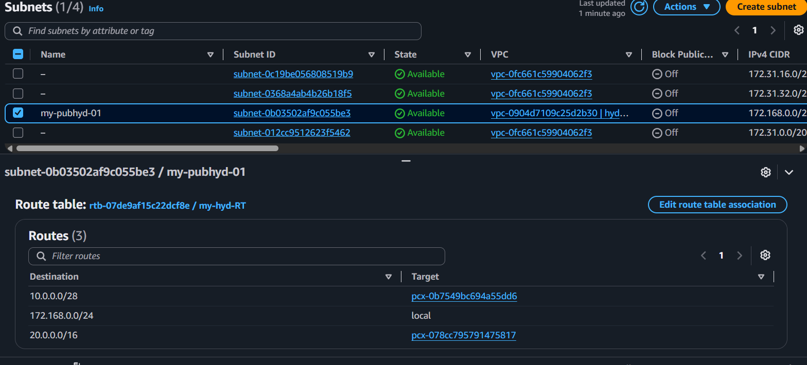
4) Set up a VPC Transit Gateway.
Step:1
Create 4 vpcs first one public subnet and remaining with private subnets
Using 4 VPC’s
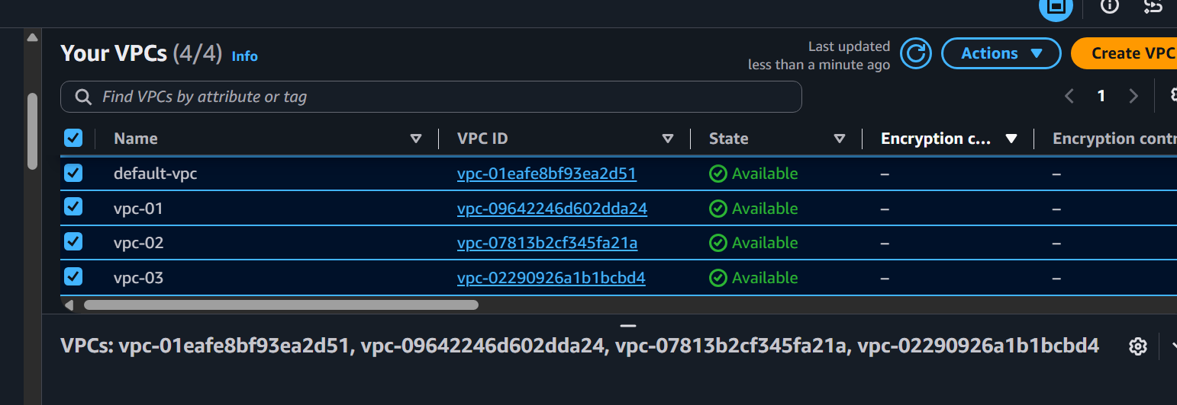
Step:2
Created subnets for all 4 VPC’s
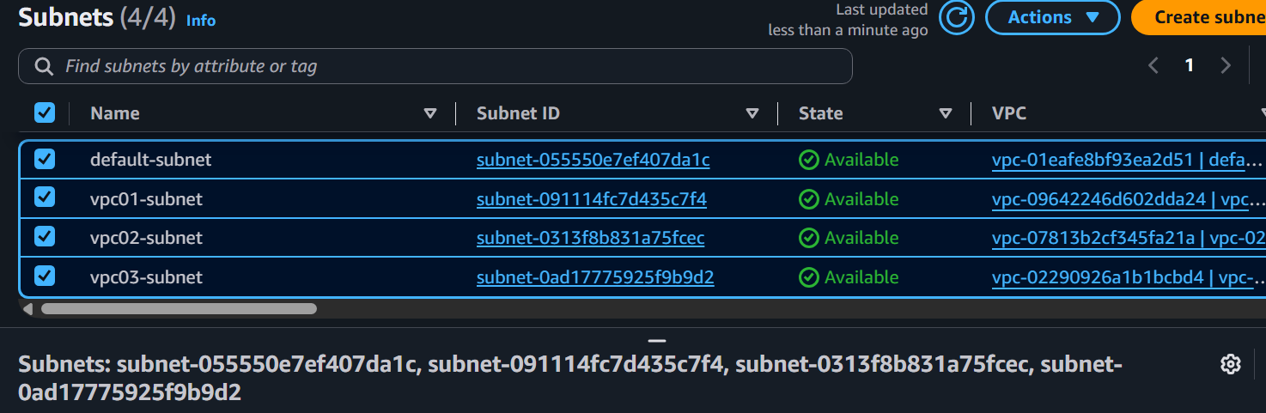
Step:3
1. Create a Transit Gateway
1. Go to VPC Console.
2. Click Transit Gateways → Create Transit Gateway.
3. Enter a Name.
4. Leave default settings.
5. Click Create Transit Gateway.
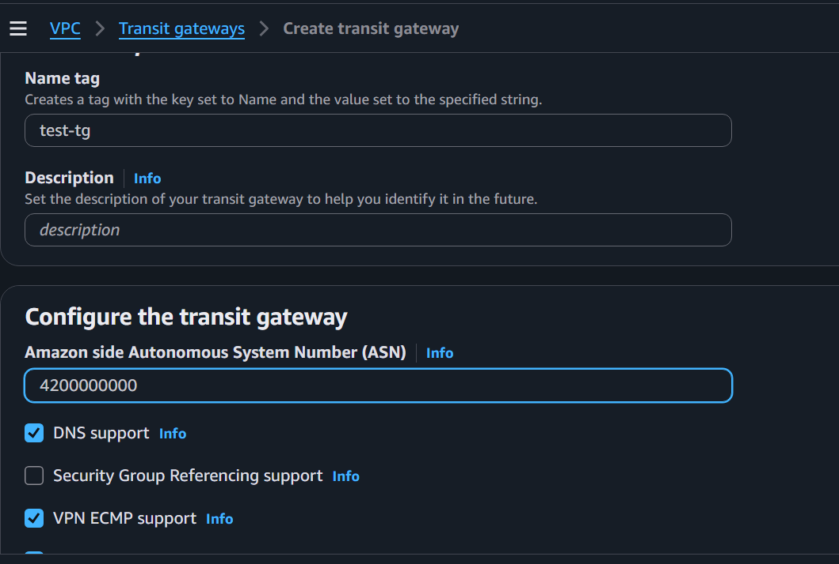
2. Create Transit Gateway Attachments
6. Go to Transit Gateway Attachments → Create Attachment.
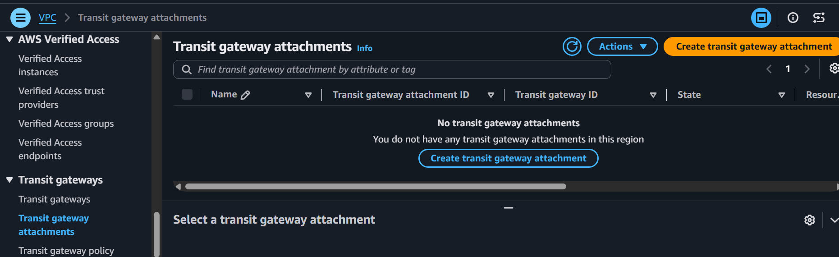
7. Select:
o Name: defult-tga
o Resource Type: VPC
o Transit Gateway: test-tgw
o VPC: my-vpc-defult
o Subnet: defult subnet
8. Click Create Attachment

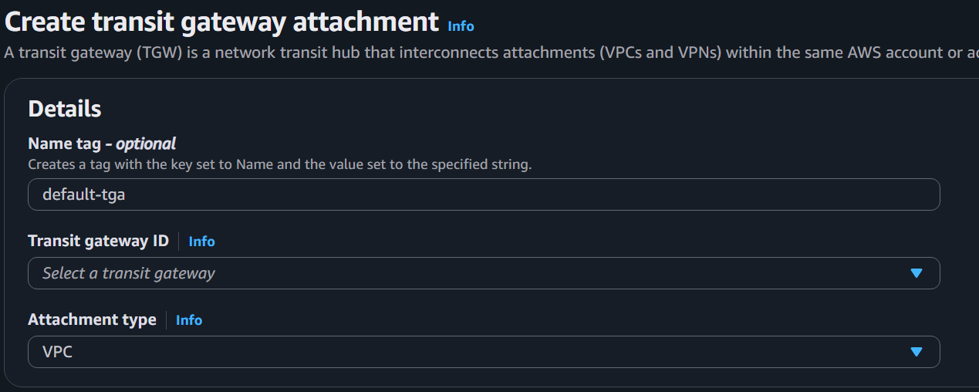
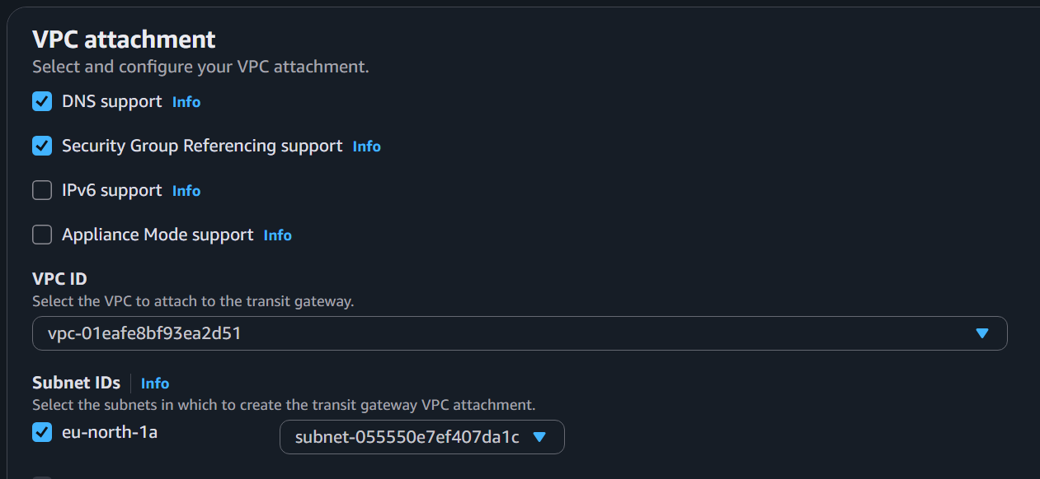
9. Repeat for each VPC you want to connect.
Create Vpc01-tga
Vpc02-tga
Vpc03-tga
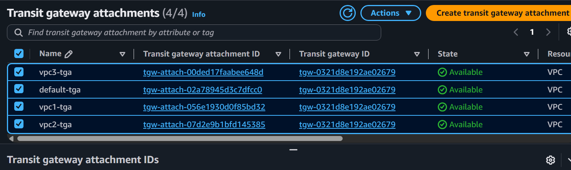
Check
VPC---Transit gateway route table-Association
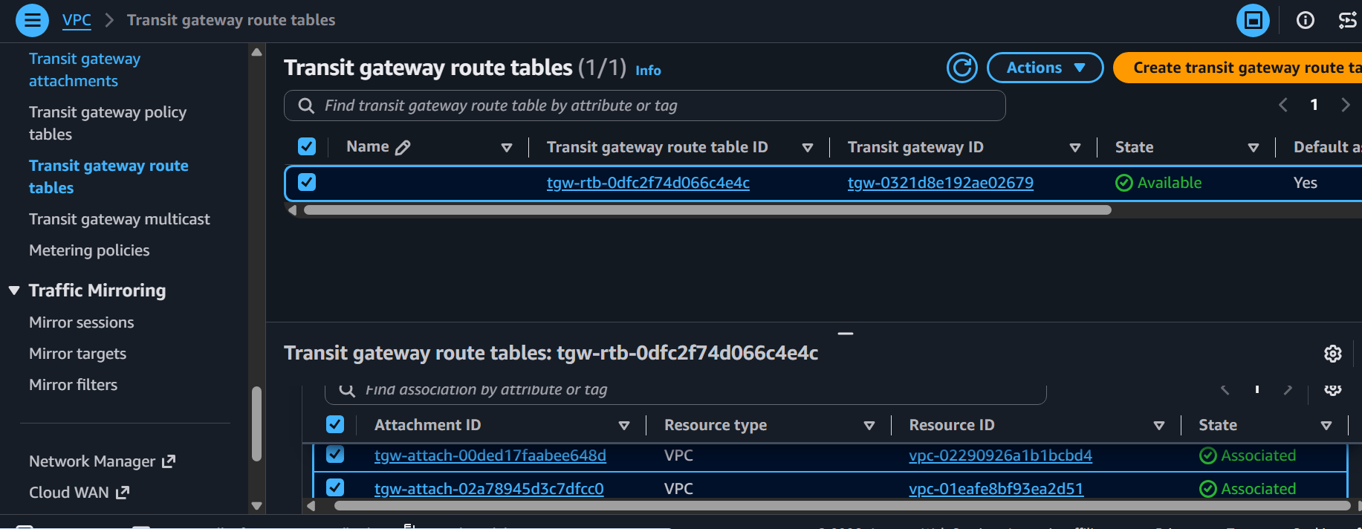
Check
VPC---Transit gateway route table-Route
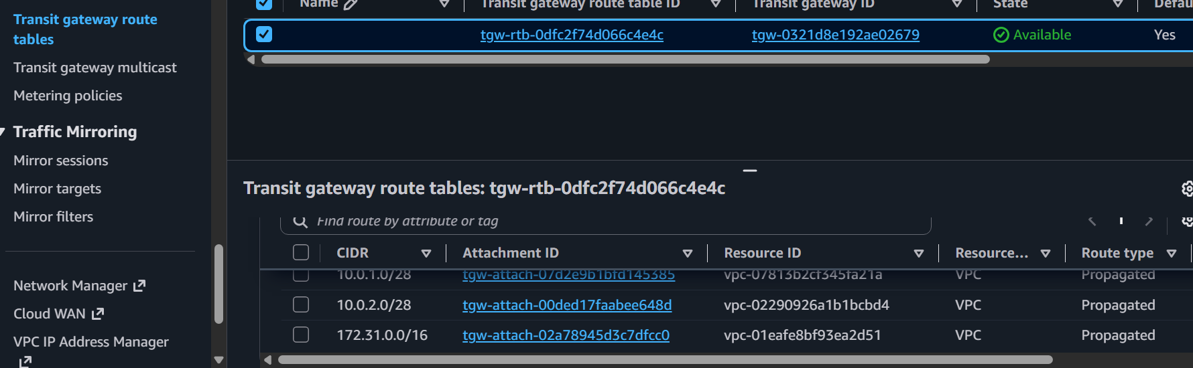
Now Launch 4 EC2 instance in 4vpc
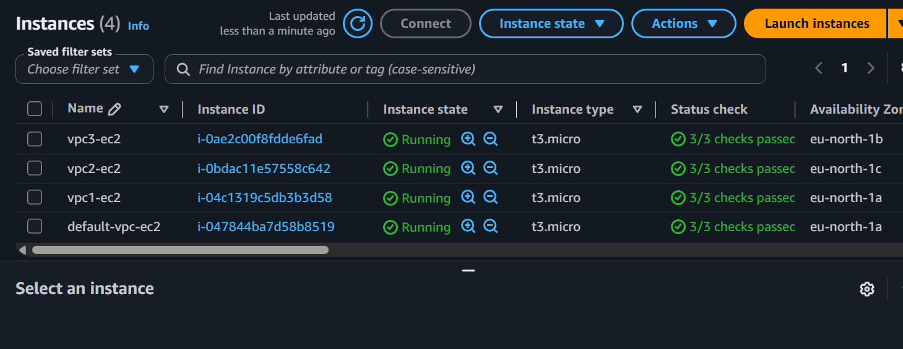
4. Update Security Groups
12. Allow required traffic
SSH and all Traffic
5. Test Connectivity
13. From one EC2 instance, ping the private IP of an EC2 in the other VPC:
Not getting connected
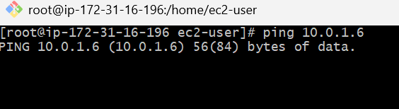
Solution
Update route table
Destination and target
Connected
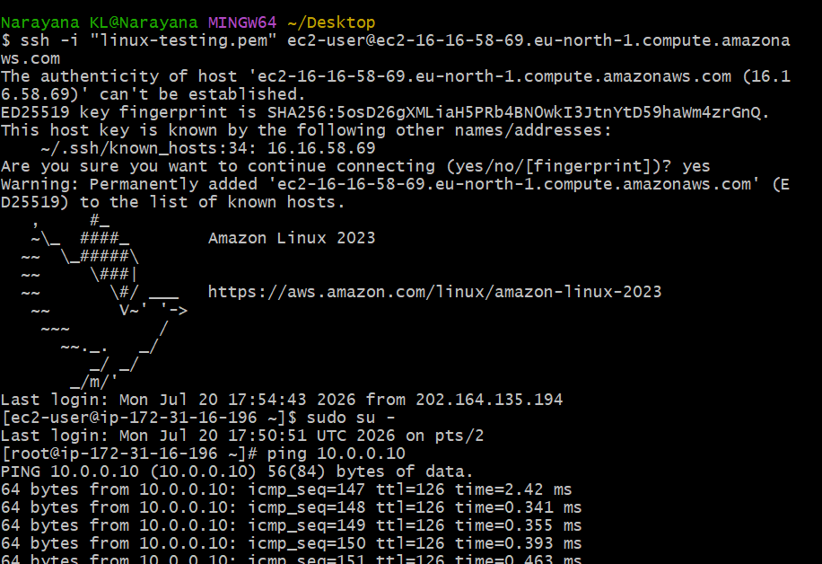
5) Set up a VPC Endpoint.
Step 1 Create VPC
VPC Name
MyVPC
CIDR
10.0.0.0/16
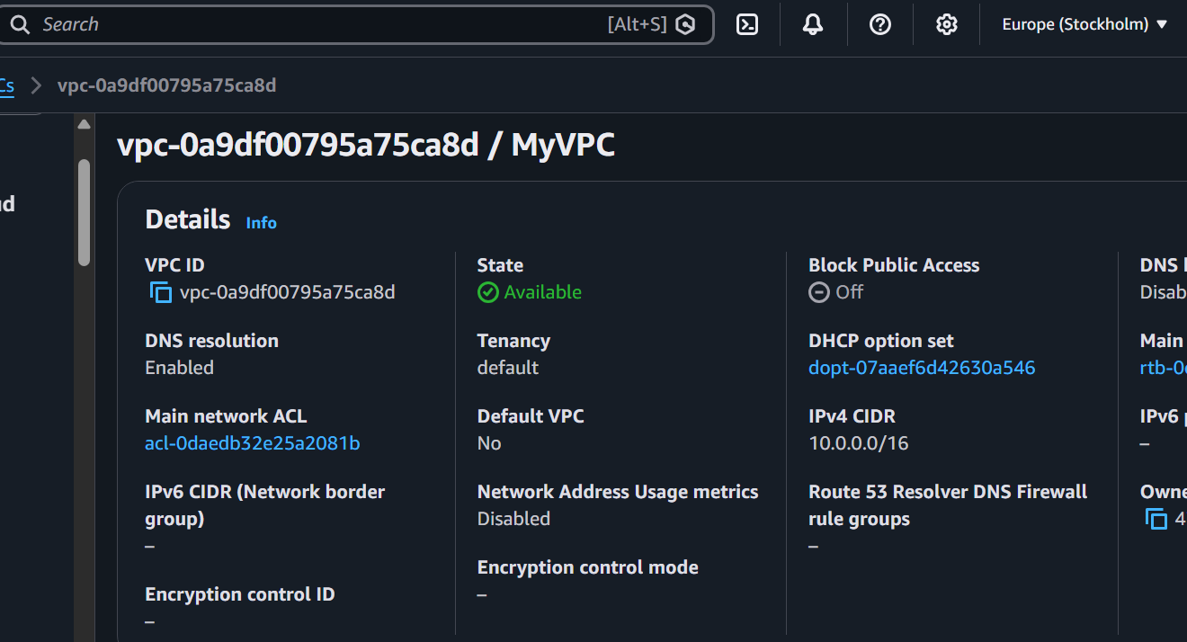
Step 2 Create Subnets
Public
10.0.1.0/24
Private
10.0.2.0/24
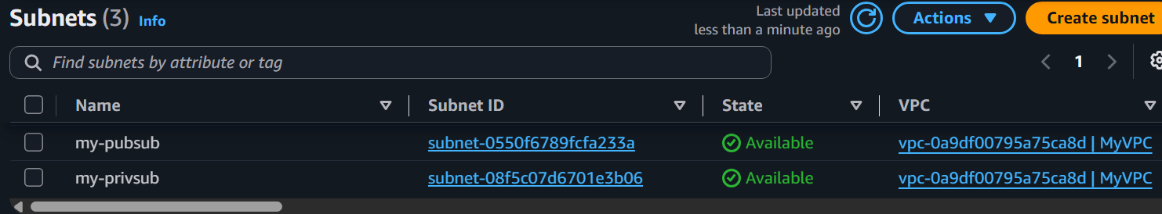
Step 3 Create Route Tables
Public Route Table
Destination Target
10.0.0.0/16 Local
0.0.0.0/0 Internet Gateway
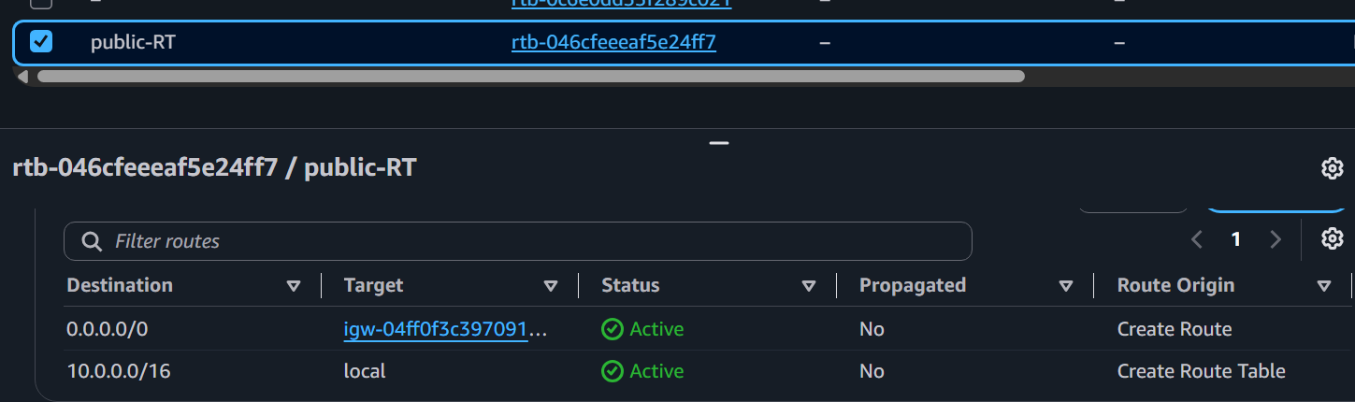
Private Route Table
Destination Target
10.0.0.0/16 Local
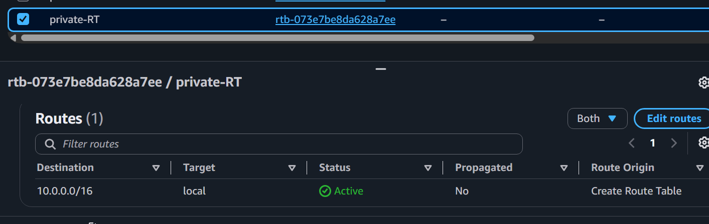
Notice
No Internet Route
No NAT Gateway
Step 4 Launch EC2
Launch
Amazon Linux 2023
Inside
Private Subnet
No Public IP
Security Group
Allow SSH from Bastion/Public EC2 (or SSM if using Session Manager).
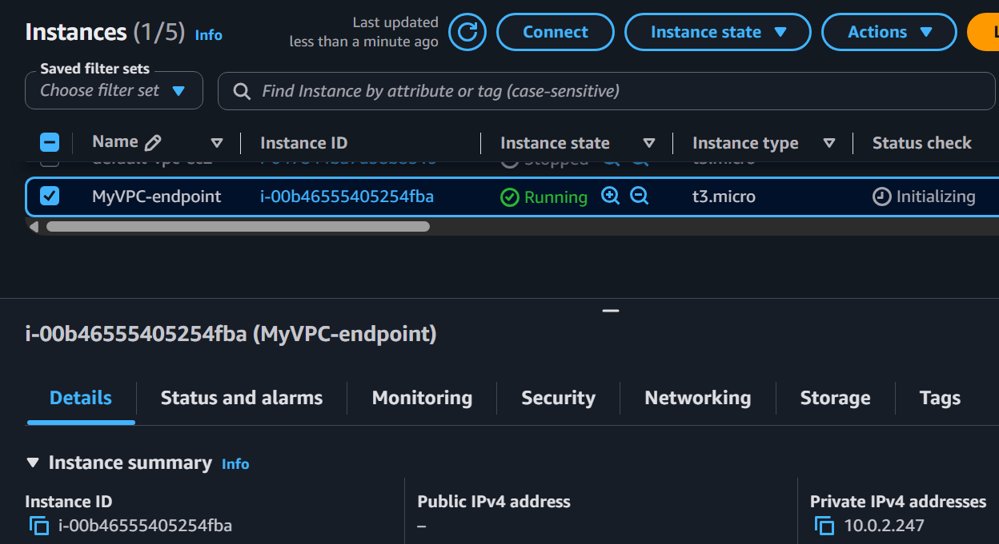
Step 5 Create S3 Bucket
Example: my-vpc-endpoint-demo
Upload
sample.txt
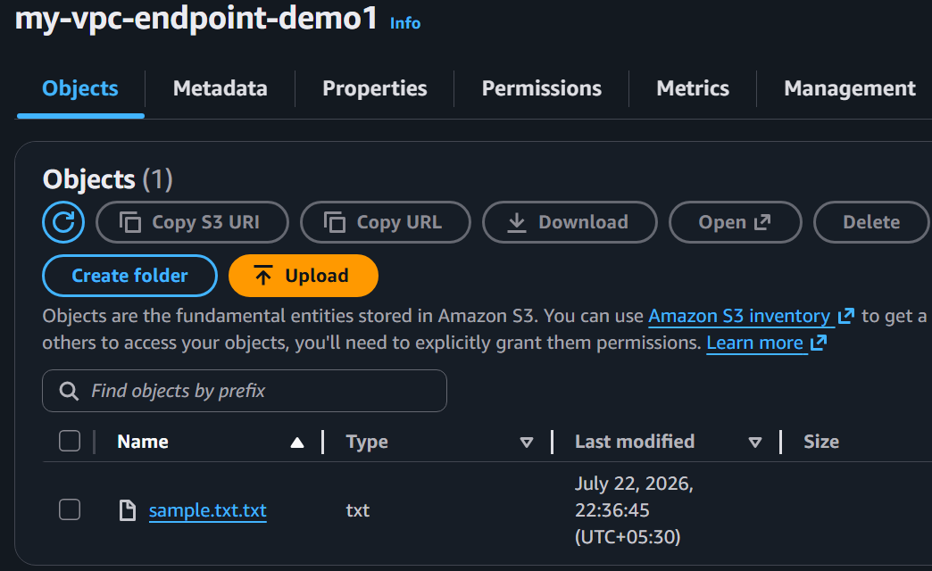
Step 6 Create Gateway Endpoint
Open
VPC Console
↓
Endpoints
↓
Create Endpoint
Configure
Name
S3Endpoint
Service Category
AWS Services
Service
com.amazonaws.<region>.s3
Example
com.amazonaws.ap-south-1.s3
Type
Gateway
Choose
MyVPC
Select Route Table
Choose
Private Route Table
AWS automatically adds a route for S3.
Click
Create Endpoint
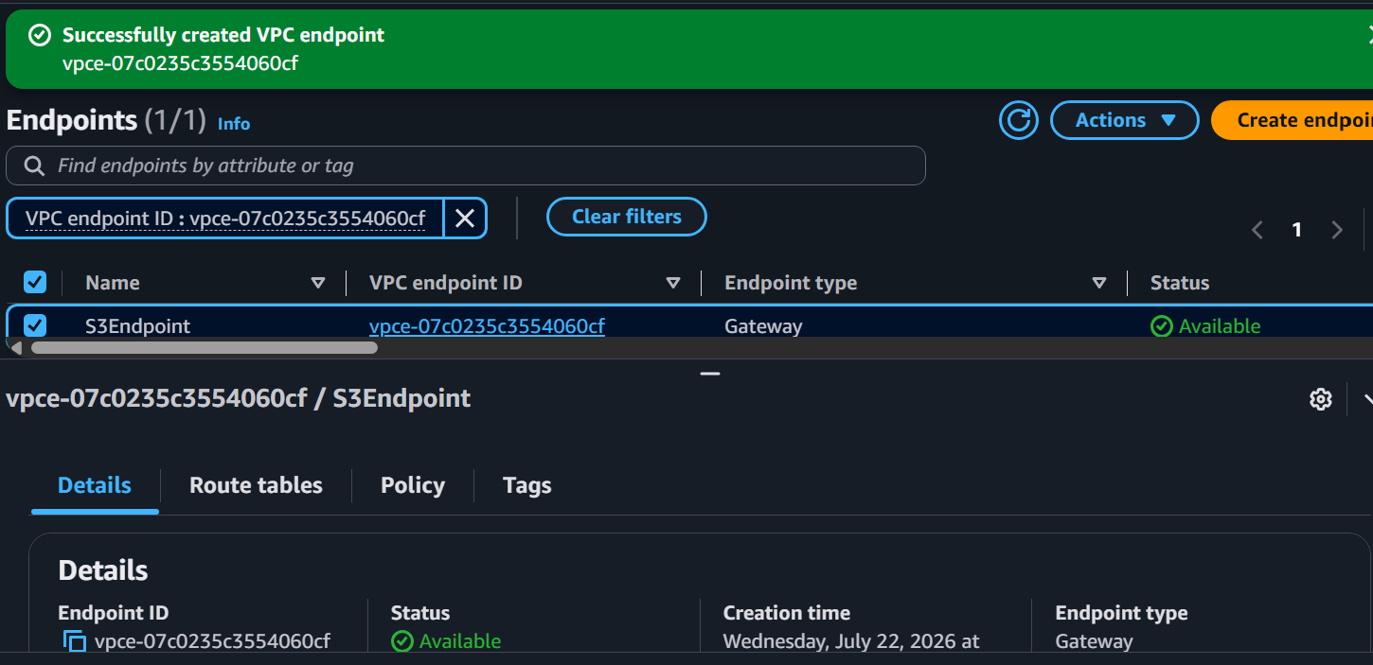
Step 7 Verify Route Table
Before
Destination Target
10.0.0.0/16 Local
After
Destination Target
10.0.0.0/16 Local
pl-xxxxxxxx VPCE
pl-xxxxxxxx is an AWS-managed prefix list representing S3 IP ranges.
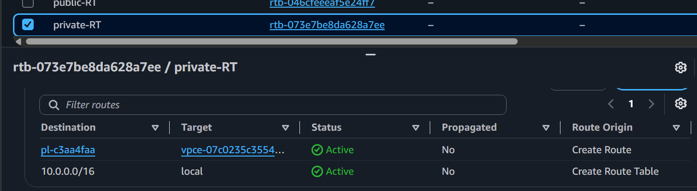
Step 8 Connect to Private EC2
Launch another EC2 instance in the public subnet.
SSH from your laptop to the public EC2:
ssh -i mykey.pem ec2-user@<public-ec2-public-ip>
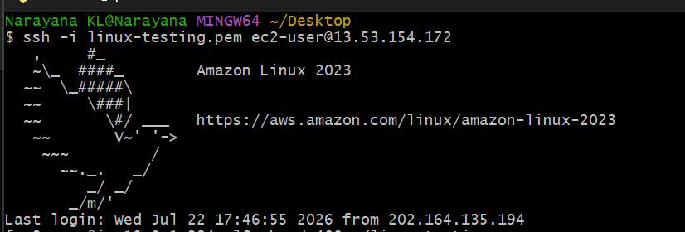
chmod 400 ~/linux-testing.pem
From the public EC2, SSH to the private EC2:
ssh -i ~/linux-testing.pem ec2-user@10.0.2.247
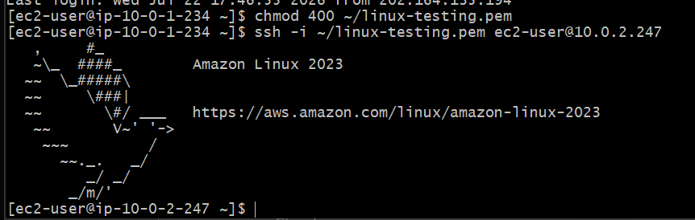
Step 9 Install AWS CLI
Amazon Linux usually comes with AWS CLI v2.
Check
aws --version
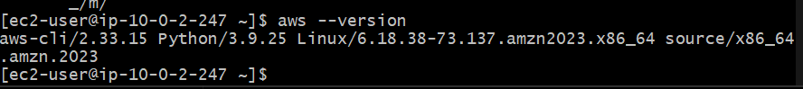
Attach an IAM Role
- Go to EC2 Console.
- Select your private EC2.
- Click Actions → Security → Modify IAM role.
- Attach an IAM role that has S3 permissions, for example:
  - AmazonS3ReadOnlyAccess (for read-only testing), or
  - AmazonS3FullAccess (for lab/testing).

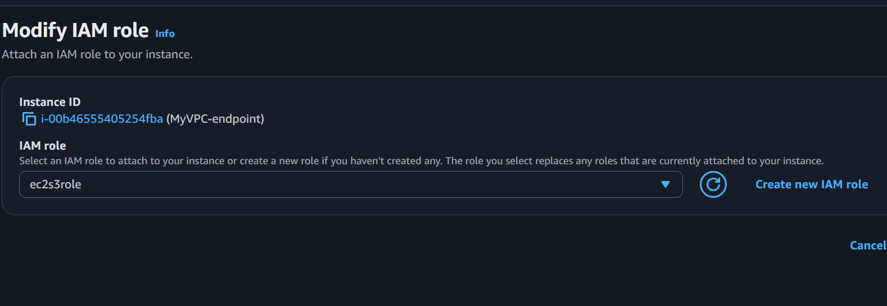
Step 10 Test S3 Access
List buckets
aws s3 ls

List files
aws s3 ls s3://my-vpc-endpoint-demo
Download file
aws s3 cp s3://my-vpc-endpoint-demo1/sample.txt .
View file
ls -l
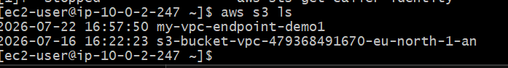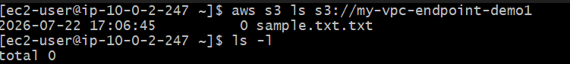
If this succeeds without internet connectivity, the VPC Endpoint is working.

